Task Rollup Solution Administrator’s Guide

1. Components: The Task Rollup Solution has the Following Eight Components
   1. Custom Content Type – Rate Review
   2. Standard Content Type – Project Task
   3. Crawled Properties
   4. Managed Properties
   5. Content Search Web Part
   6. Custom Search Query
   7. Custom Control Template
   8. Custom Item Display Template
2. Custom Content Type – Rate Review: The Site Collection Level “Rate Review” Custom Content Type
   1. Used in all Rate Review libraries as the default task content type
   2. Contains the following fields and field types:

|  |  |
| --- | --- |
| Name | Type |
| Data Request Topic | Lookup |
| DR Lookup | Lookup |
| Date Received | Date and Time (Date Only) |
| Date Response Due for Review | Date and Time (Date Only) |
| [DR Number](https://bentest.bhcorp.ad/sites/regulatory3/wyoming/gasratereview/_layouts/15/FldEdit.aspx?List=%7BABAB0A29%2D6E4E%2D4C29%2D95D3%2D7FBD9D787082%7D&Field=DR%5Fx0020%5FNumber) | Single Line of Text |
| Externally Confidential | Choice |
| Filed Date | Date and Time (Date Only) |
| Internal Confidential | Yes/No (Boolean) |
| Intervenor Name | Single Line of Text |
| Intervenor Set | Single Line of Text |
| Notes | Multiple Lines of Text |
| Objection | Yes/No (Boolean) |
| Regulatory Partner | Person or Group |
| Response Preparer | Person or Group |
| Review Date | Date and Time (Date Only) |
| Review Task Status | Choice |
| SME Approver | Person or Group |
| Status | Choice |
| Title | Single Line of Text |
| Type of Document | Choice |
| Content Type | Property |
| Highly Confidential | Yes/No (Boolean) |
| File Name | Single Line of Text |
| Objection | Yes/No (Boolean) |
| Task URL | Single Line of Text |
| Task Due Date | Date and Time (Date Only) |

1. Standard Content Type – Project Task: The Site Collection Level “Task” Standard Content Type
   1. Used in all Project Task libraries as the default task content type
   2. Contains the following fields and field types:

|  |  |
| --- | --- |
| Name | Field Type |
| Assigned To | Person or Group |
| Due Date | Date and Time (Date Only) |
| Content Type | Property |
| Start Date | Date and Time (Date Only) |
| Title | Single Line of Text |

1. Crawled Properties: Refer to “My Task Rollup Content Type” Excel Document
2. Managed Properties: Refer to “My Task Rollup Content Type” Excel Document
3. Content Search Web Part:
   1. The Content Search Web Part is configured to query and display rate review tasks for the Current User and from the Entire Site Collection
   2. The Content Search Web Part requires the following four configurations:

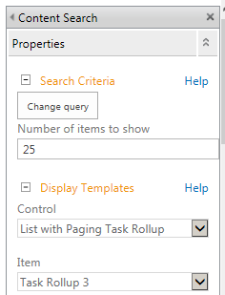

* + 1. Content Search Query – See Item 6
    2. Number of Items to Display – 25
    3. Control – List with Paging Custom Task Rollup
    4. Item – Custom Task Rollup

1. Custom Query (Code and Explanation):
   1. Complete Query:

{searchTerms} (ContentType:"Rate Review" (RegulatoryPartnerOWSUSER:{User.Name} OR SMEApproverOWSUSER:{User.Name} OR ResponsePreparerOWSUSER:{User.Name}) AND ( ReviewTaskStatusOWSCHCS<>Final AND ReviewTaskStatusOWSCHCS<>Served)) OR (ContentType:"Task” AssignedTo:{User.Name} AND PercentCompleteOWSNMBR<>1)

* 1. Content Type – What Kind of Data Will be Returned – Rate Review:

ContentType:"Rate Review"

* 1. Content Type – What Kind of Data Will be Returned – Project Task:

ContentType:"Task”

* 1. Filter 1 – Only Return Rate Review Items that the Current User is Tasked to Act On:

(ResponsePreparerOWSUSER={User.Name} OR RegulatoryPartnerOWSUSER={User.Name} OR SMEApproverOWSUser={User.Name})

* 1. Filter 2 – Don’t Return Rate Review Items Where Review Task Status Equals Final or Served:

(ReviewTaskStatusOWSCHCS<>Final AND ReviewTaskStatusOWSCHCS<>Served)

* 1. Filter 3 – Only Return Project Task Items that the Current User is Tasked to Act On:

AssignedTo:{User.Name}

* 1. Filter 4 – Only Return Project Task Items that are Not Complete:

PercentCompleteOWSNMBR<>1

1. Download Design Files from the Development Team Docs Library
   1. Navigate to the Development Team Docs Library:

<https://ben.blackhillscorp.com/sites/Regulatory/Development%20Team%20Docs/Forms/All%20Douments.aspx>

* 1. Download the Following Two Files:
     1. Control_ListWithPagingTaskRollup_New.html (Title: Control List with Paging Custom Task Rollup New)
     2. Item_TaskRollup_New.html (Title: Item Task Rollup New)

1. Upload Design Files to the Master Page Gallery
   1. From the Site Collection Top Site Click on the Site Settings Cog
   2. From the Drop-Down Menu Choose Site Settings
   3. From the Site Settings Page, Under the Look and Feel Header, Click on the Design Manager
   4. From the Design Manager: Welcome Page Click on “3. Upload Design Files”
   5. From the Design Manager: Upload Design Files Page Click Copy the Location URL and Paste It in a New Tab
   6. From the Master Page Gallery Page Click on the Display Templates Folder
   7. From the Master Page Gallery Display Templates Page Click on the Content Web Parts Folder
   8. From the Display Templates Content Web Parts Page Click on the Files Tab and then the Upload Icon
   9. Upload Both the “Control_ListWithPagingTaskRollup_New.html” and “Item_TaskRollup_New.html” Files
2. Code Comments – Control List with Paging Task Rollup New:
   1. Rate Review Code:

<table id="tableRollUp">

<tr style="text-align:center; background:#504A4B; color:white;">

<th colspan="12" width="100%">Rate Review Tasks</th>

</tr>

<tr style="text-align:center; background:#F88007; color:white;">

<th colspan="12" width="100%">Project Title | File Name | Task List</th>

</tr>

<tr style="text-align:center; background:#F88007; color:white;">

<th rowspan="2" width="75px">Status</th>

<th rowspan="2" width="75px">Party Name</th>

<th rowspan="2" width="75px">Party Set</th>

<th rowspan="2" width="50px">DR Number</th>

<th rowspan="2" width="85px">Doc Type</th>

<th rowspan="2" width="85px">Data Request Topic</th>

<th rowspan="2" width="85px">Date Received</th>

<th rowspan="2" width="85px">Date Response Due</th>

<th rowspan="2" width="85px">Due Date</th>

<th rowspan="2" width="85px">Review Date</th>

<th rowspan="2" width="85px">Served Date</th>

<th rowspan="2" width="50px">Objection</th>

</tr>

<tr><td>&nbsp;</td></tr>

<tr style="text-align:center; background:#F88007; color:white;">

<th rowspan="2" colspan="4">Highly Confidential</th>

<th rowspan="2" colspan="4">Internally Confidential</th>

<th rowspan="2" colspan="4">Externally Confidential</th>

</tr>

<tr><td>&nbsp;</td></tr>

<tr style="text-align:center; background:#F88007; color:white;">

<th rowspan="2" colspan="4">Regulatory Partner</th>

<th rowspan="2" colspan="4">Response Preparer</th>

<th rowspan="2" colspan="4">SME Approver</th>

</tr>

<tr><td>&nbsp;</td></tr>

* 1. Project Task Code:

<tr style="text-align:center; background:#504A4B; color:white;">

<th colspan="12" width="100%">Project Tasks</th>

</tr>

<tr style="text-align: Center; background:#F88007; color:white;">

<th rowspan="2" colspan="12" width="200px">Project | Task Name</th>

</tr>

<tr><td>&nbsp;</td></tr>

<tr style="text-align:Center; background:#F88007; color:white;">

<th rowspan="2" colspan="4">Assigned To</th>

<th rowspan="2" colspan="4">Start Date</th>

<th rowspan="2" colspan="4">Due Date</th>

</tr>

</table>

1. Code Comments – Item Task Rollup New:
   1. Managed Property Mapping:

<mso:ManagedPropertyMapping msdt:dt="string">

'Link URL'{Link URL Label}:'Path',

'Title'{Title Label}:'Title',

'Status'{Status Label}:'StatusOWSCHCS',

'Intervenor'{Intervenor Label}:'IntervenorNameOWSTEXT',

'Review Task Status'{Review Task Status}:'ReviewTaskStatusOWSCHCS',

'Party Name'{Party Name}:'PartyNameOWSTEXT',

'Party Set'{Party Set}:'PartySetOWSTEXT',

'DR Number'{DR Number Label}:'DRNumberOWSTEXT',

'Data Request Topic'{Data Request Topic Label}:'DataRequestTopicOWSCHCS',

'DR Lookup'{DR Lookup Label}:'DRLookupOWSCHCS',

'Date Received'{Date Received Label}:'DateReceivedOWSDATE',

'Date Response Due'{Date Response Due Label}:'DateResponseDueforReviewOWSDATE',

'Review Date'{Review Date Label}:'ReviewDateOWSDATE',

'Due Date'{Due Date Label}:'DueDateOWSDATE',

'File Name'{File Name Label}:'Filename',

'Filed Date'{Filed Date Label}:'FiledDateOWSDATE',

'Served Date'{Served Date}:'ServedDateOWSDATE',

'Externally Confidential'{Externally Confidential Label}:'ExternallyConfidentialOWSBOOL',

'Highly Confidential'{Highly Confidential Label}:'HighlyConfidentialOWSBOOL',

'Objection'{Objection Label}:'ObjectionOWSBOOL',

'Internally Confidential'{Internally Confidential Label}:'InternalConfidentialOWSBOOL',

'Intervenor Set'{Intervenor Set Label}:'IntervenorSetOWSTEXT',

'Regulatory Partner'{Regulatory Partner Label}:'RegulatoryPartnerOWSUSER',

'Response Preparer'{Response Preparer Label}:'ResponsePreparerOWSUSER',

'Objection'{Objection Label}:'ObjectionOWSBOOL',

'SME Approver'{SME Approver Label}:'SMEApproverOWSUser',

'Type of Document'{Type of Document}:'DocTypeOWSCHCS',

'Site Title'{Site Title Label}:'SiteTitle',

'Task URL'{Task URL Label}:'TaskURLOWSTEXT',

'Due Date'{Due Date Label}:'DueDateOWSDATE',

'Start Date'{Start Date Label}:'StartDateOWSDATE',

'Assigned To'{Assigned To Label}:'AssignedToOWSUSER',

'Content Type'{Content Type Label}:'ContentType',

'Line 1'{Line 1}:'Title'

</mso:ManagedPropertyMapping>

* 1. Includes – Script:

RegisterSod('jquery-1.11.3.min.js', Srch.U.replaceUrlTokens("~sitecollection/_catalogs/masterpage/Display Templates/Search/jquery-1.11.3.min.js"));

* 1. Variables – Script:

//*** General Variables ***//

var encodedId = $htmlEncode(ctx.ClientControl.get_nextUniqueId() + "_2lines_");

var linkURL = $getItemValue(ctx, "Link URL");

linkURL.overrideValueRenderer($urlHtmlEncode);

var iconURL = Srch.ContentBySearch.getIconSourceFromItem(ctx.CurrentItem);

var line1 = $getItemValue(ctx, "Line 1");

line1.overrideValueRenderer($contentLineText);

var pictureLinkId = encodedId + "pictureLink";

var pictureId = encodedId + "picture";

var linkURL = $getItemValue(ctx, "Link URL");

//*** Content Type ***//

var contentType = $getItemValue(ctx, "Content Type");

var contentTypeSD = contentType.value;

var strContentTypeSD1 = contentTypeSD.toString();

var strContentTypeSD2 = strContentTypeSD1.replace('application/vnd.openxmlformats-officedocument.wordprocessingml.document',' ');

var strContentTypeSD2Trim = strContentTypeSD2.trim();

//*** Rate Review ***//

var title = $getItemValue(ctx, "Title");

var status = $getItemValue(ctx, "Status");

var reviewtaskstatus = $getItemValue(ctx, "Review Task Status");

var drnumber = $getItemValue(ctx, "DR Number");

var drlookup = $getItemValue(ctx, "DR Lookup");

var doctype = $getItemValue(ctx, "Type of Document");

var filename = $getItemValue(ctx, "File Name");

var Objection = $getItemValue(ctx, "Objection");

var exconfidential = $getItemValue(ctx, "Externally Confidential");

var objection = $getItemValue(ctx, "Objection");

var inconfidential = $getItemValue(ctx, "Internally Confidential");

var highlyconfidential = $getItemValue(ctx, "Highly Confidential");

var sitetitle = $getItemValue(ctx, "Site Title");

//*** Party Manipulation ***//

///Party Name

var partyname = $getItemValue(ctx, "Intervenor");

var strpartyname = partyname.toString();

var partynameST = strpartyname.replace(/;/g,", ");

///Party Set

var partyset = $getItemValue(ctx, "Intervenor Set");

var strpartyset = partyset.toString();

var partysetST = strpartyset.replace(/;/g,", ");

//*** Data Request Topic Manipulation ***//

var datareqtopic = ctx.CurrentItem.DRLookupOWSCHCS;

var datareqtopicST = datareqtopic.replace(/;/g,", ");

//*** Dates Manipulation ***//

///Date Recieved - Additional Code to Correct Date and Time Included Issue

var datereceived = ctx.CurrentItem.DateReceivedOWSDATE;

if (datereceived != null){var datereceivedSD = datereceived.split('T')[0];}

//var strDate = datereceivedSD.toString();

//var dtInclude = strDate.search(';');

//if (dtInclude != -1){

//alert("dtInclude " + dtInclude)

//var index1 = datereceived.indexOf(';');

//var index2 = datereceived.indexOf('T');

//var datereceivedST = datereceived.slice(index1, index2);

//var datereceivedSD = datereceivedST.replace(/;/g, '');

//};

///Date Response Due

var dateresponsedue = ctx.CurrentItem.DateResponseDueforReviewOWSDATE;

if (dateresponsedue != null){var dateresponsedueSD = dateresponsedue.split('T')[0];}

///Review Date

var reviewdate = ctx.CurrentItem.ReviewDateOWSDATE;

if (reviewdate != null){var reviewdateSD = reviewdate.split('T')[0];}

///Filed or Served Date

var fileddate = ctx.CurrentItem.ServedDateOWSDATE;

//alert("Filed Date = " + fileddate);

if (fileddate != null){var fileddateSD = fileddate.split('T')[0];}

//var strDate2 = fileddateSD.toString();

//var dtInclude2 = strDate2.search(';');

//if (dtInclude2 != -1){

////alert("dtInclude 2c" + dtInclude2)

//var index3 = fileddate.indexOf(';');

//var index4 = fileddate.indexOf('T');

//var fileddateST = fileddate.slice(index3, index4);

//var fileddateSD = fileddateST.replace(/;/g, '');

//};

///Due Date

var duedate = ctx.CurrentItem.TaskDueDateOWSDATE;

if (duedate != null){var duedateSD = duedate.split('T')[0];}

//*** People Picker Manipulation ***//

///Regulatory Partner

var regulatorypartner = ctx.CurrentItem.RegulatoryPartnerOWSUSER;

if (regulatorypartner != null){var regulatorypartnerSN = regulatorypartner.split('|')[1];}

///Response Preparer

var responsepreparer = ctx.CurrentItem.ResponsePreparerOWSUSER;

if (responsepreparer != null){var responsepreparerSN = responsepreparer.split('|')[1];}

///SME Approver

var smeapprover = ctx.CurrentItem.SMEApproverOWSUser;

if (smeapprover != null){var smeapproverSN = smeapprover.split('|')[1];}

//*** Task URL ***//

var taskurl = $getItemValue(ctx, "Task URL");

//strURL7 = taskurl;

var strURL = taskurl.toString();

var strURL1 = strURL.replace('&lt;','<');

var strURL2 = strURL1.replace('&quot;','"');

var strURL3 = strURL2.replace('&quot;','"');

var strURL4 = strURL3.replace('&gt;','>');

var strURL5 = strURL4.replace('&lt;','<');

var strURL6 = strURL5.replace('&gt;','>');

var strURL7 = strURL6.replace('a','a style="color:white;"');

//*** Project Tasks ***//

///Assigned To

var assignedTo0 = $getItemValue(ctx, "Assigned To");

var assignedTo1 = assignedTo0.toString();

var count = (assignedTo1.split(",").length - 1); // Get the count of the number of ','

if (count <= 2){ // One Assignee

var assignedto0 = $getItemValue(ctx, "Assigned To"); // Get the Assigned To value

var assignedto1 = assignedto0.toString(); // Set the variable to string

var assignedto2 = assignedto1.indexOf(','); // Get the location of the first ','

var assignedto3 = assignedto1.slice(0,assignedto2); // Get the last name

var assignedto4 = assignedto1.lastIndexOf(','); // Get the location of the last ','

var assignedto5 = assignedto1.slice(assignedto4); // Get the first name

var assignedto6 = assignedto5 + " " + assignedto3; // Combine the first and last name

var assignedto7 = assignedto6.slice(1); // Remove the ','

var strAssignedTo = assignedto7.trim(); // Remove leading white spaces

} else { // Two Assignees

//Declare String Variables

var assignedto0 = $getItemValue(ctx, "Assigned To");

var assignedto1 = assignedto0.toString(); //Get the full string

var assignedto2 = assignedto1.indexOf(','); // Get the location of the first ','

var assignedto3 = assignedto2 + 1; // Add one to get text after the first ','

var assignedto4 = assignedto1.indexOf(',', assignedto3); // Get the location of the second ','

//First Assignee

var assignedto5 = (assignedto1.slice(0,assignedto4)).toString(); // Get the first assignee string -

var assignedto6 = assignedto5.indexOf(','); // Get the location of the ',' in the first assignee

var assignedto7 = assignedto5.slice(assignedto6 + 1); // Get the first name - ex: Jennifer

var assignedto8 = assignedto5.slice(0, assignedto6); // Get the last name - ex: Jernigan

var assignedto9 = assignedto7 + " " + assignedto8 + ", "; // Restructure the name to be first last plus ','

//Second Assignee

var assignedto10 = assignedto1.indexOf(',', assignedto4 + 1); // Get the location of the third ',' - ex: 26

var assignedto11 = assignedto1.slice(assignedto4 + 1, assignedto10); // Get the last name - ex: Molskow

var assignedto12 = assignedto1.lastIndexOf(','); // Get the location of the last ',' - ex: 56

var assignedto13 = assignedto1.slice(assignedto12 + 1); // Get the first name - ex: Tom

var assignedto14 = assignedto13 + " " + assignedto11

//Combined Assignees

var assignedto15 = assignedto9 + " " + assignedto14 // Combined Assignees

//Display

var strAssignedTo = assignedto15; // Display String

}

///Task Start Date

//var startdate = $getItemValue(ctx, "Start Date");

var startdate = ctx.CurrentItem.StartDateOWSDATE;

if (startdate != null){var startdateSD = startdate.split('T')[0];}

if (startdate == null){var startdateSD = "No Start Date Chosen";}

///Task Due Date

var taskduedate = ctx.CurrentItem.DueDateOWSDATE

if (taskduedate != null){var taskduedateSD = taskduedate.split('T')[0];}

if (taskduedate == null){var taskduedateSD = "No Due Date Chosen";}

* 1. Display Code – Script:

<!-- *** Check Content Type - If Not Rate Review then Project Task *** -->

<!--#_

if(strContentTypeSD2Trim != "Rate Review")

{

_#-->

<table>

<tr>

<th colspan="15" width="1100px" style="text-align:center; background:#504A4B; color:white;">

Project Task

</th>

</tr>

<tr>

<td colspan="15" width="100%" style="text-align:center; background:grey; color:white;">

<a href=" _#=linkURL =#_ " style="color:white;"> _#= sitetitle =#_ | _#= title =#_ </a>

<!-- *** Check Rate Review Item - Has a Task Been Created *** -->

<!--#_

if(strURL7 != ""){

_#-->

| _#= strURL7 =#_

<!--#_

}

_#-->

</td>

</tr>

<tr>

<td rowspan="2" colspan="4" style="text-align:center; border:0.5px solid #F88007;">

_#= strAssignedTo =#_ </td>

<td rowspan="2" colspan="4" style="text-align:center; border:0.5px solid #F88007;">

_#= startdateSD =#_ </td>

<td rowspan="2" colspan="4" style="text-align:center; border:0.5px solid #F88007;">

_#= taskduedateSD =#_ </td>

</tr>

</table>

<!--#_

}

_#-->

<!-- Check Content Type - Is It Rate Review? -->

<!--#_

if(strContentTypeSD2Trim == "Rate Review")

{

_#-->

<table>

<tr>

<th colspan="15" width="900px" style="text-align:center; background:#504A4B; color:white;">

Rate Review Task

</th>

</tr>

<tr>

<td colspan="15" width="100%" style="text-align:center; background:grey; color:white;">

<a href=" _#=linkURL =#_ " style="color:white;"> _#= sitetitle =#_ | _#= filename =#_ </a>

<!--#_

if(strURL7 != ""){

_#-->

| _#= strURL7 =#_

<!--#_

}

_#-->

</td>

</tr>

<tr style="text-align:left;">

<td rowspan="3" width="75px">_#= reviewtaskstatus =#_</td>

<td rowspan="3" width="75px" style="text-align:center;"> _#= partynameST =#_ </td>

<td rowspan="3" width="75px" style="text-align:center;"> _#= partysetST =#_ </td>

<td rowspan="3" width="50px" style="text-align:center;"> _#= drnumber =#_ </td>

<td rowspan="3" width="85px" style="text-align:center;"> _#= doctype =#_ </td>

<td rowspan="3" width="85px" style="text-align:center;"> _#= datareqtopicST =#_ </td>

<td rowspan="3" width="85px" style="text-align:center;"> _#= datereceivedSD =#_ </td>

<td rowspan="3" width="85px" style="text-align:center;"> _#= dateresponsedueSD =#_ </td>

<td rowspan="3" width="85px" style="text-align:center;"> _#= duedateSD =#_ </td>

<td rowspan="3" width="85px" style="text-align:center;"> _#= reviewdateSD =#_ </td>

<td rowspan="3" width="85px" style="text-align:center;"> _#= fileddateSD =#_ </td>

<td rowspan="3" width="50px" style="text-align:center;"> _#= Objection =#_ </td>

</tr>

<tr><td>&nbsp;</td></tr>

<tr><td>&nbsp;</td></tr>

<tr style="text-align:center; border:0.5px solid #F88007;">

<td rowspan="2" colspan="4" style="text-align:center; border:0.5px solid #F88007;">

_#= highlyconfidential =#_</td>

<td rowspan="2" colspan="4" style="text-align:center; border:0.5px solid #F88007;">

_#= inconfidential =#_ </td>

<td rowspan="2" colspan="4" style="text-align:center; border:0.5px solid #F88007;">

_#= exconfidential =#_ </td>

</tr>

<tr><td>&nbsp;</td></tr>

<tr style="text-align:center; border:0.5px solid #F88007;">

<td rowspan="2" colspan="4" style="text-align:center; border:0.5px solid #F88007;">

_#= regulatorypartnerSN =#_ </td>

<td rowspan="2" colspan="4" style="text-align:center; border:0.5px solid #F88007;">

_#= responsepreparerSN =#_ </td>

<td rowspan="2" colspan="4" style="text-align:center; border:0.5px solid #F88007;">

_#= smeapproverSN =#_ </td>

</tr>

<tr><td>&nbsp;</td></tr>

<!--#_

}

_#-->

1. Configuring the Content Search Web Part:
   1. From the Pages library add the Web Part Page to the libraries available Content Types:
      1. From the site click on the Site Actions Cog, and choose “Site Contents” from the drop-down menu

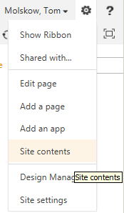

* + 1. From the Site Contents page click on the “Pages” library icon.



* + 1. From the Pages library click on the Library tab, and then click on the Library Settings icon.
    2. From the Pages Settings page, in the Content Types section, click on the “Add from existing content types” link.
    3. From the Settings Add Content Types page, under Available Site Content Types, choose Web Part Page, and then click the Add button.

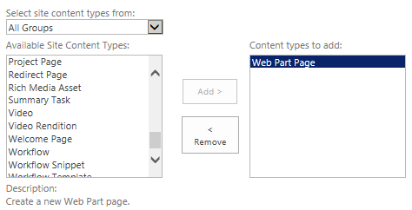

* + 1. Finally click the OK button, this will return you to the Pages Settings page.
    2. Click on the word “Pages” in the header of the page, this will return you to the Pages library’s main page.
  1. Create a Web Part Page:
     1. In the Menu Ribbon click on the Files tab
     2. From the Files tab click on the New Document icon and from the drop down choose Web Part Page

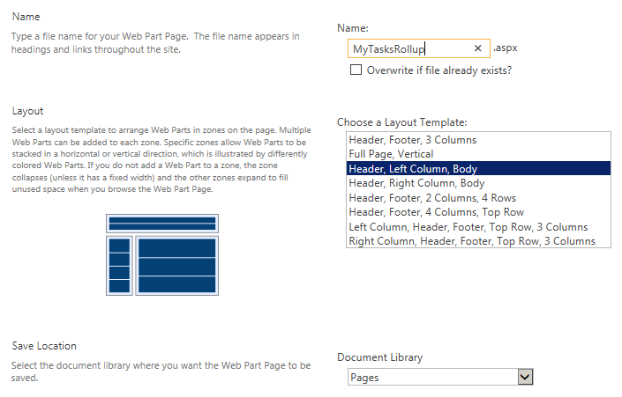

* + 1. From the Site Contents New Web Part page take the following actions:
       1. Name: MyTasksRollup
       2. Layout: Header, Left Column, Body
       3. Document Library: Pages
       4. Click on Create
       5. This will bring you to the Web Part page
  1. Add the Configurations and Code for the MY Tasks Rollup solution:
     1. From the new MyTasksRollup page, click on the “Add a Web Part” link in the Header Zone, this will open the “Insert a Web Part” pane at the top of the page
     2. In the Categories section scroll down and click on the “Content Rollup” section
     3. In the Parts section click on the Content Search web part

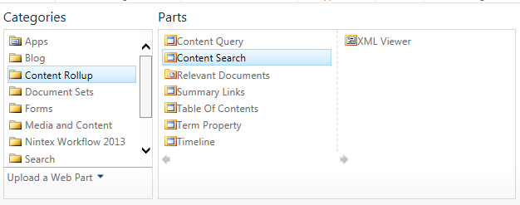

* + 1. Finally, at the far right of the “Insert a Web Part” pane, click “Add”; this will close the Insert a Web Part pane
    2. Now, with the Content Rollup web part added, click on the (very!) small drop-down arrow in the web part, and from the drop down choose the “Edit Web Part” menu item; this will open the Edit Web Part pane on the right
    3. From the Edit Web Part pane take the following actions:

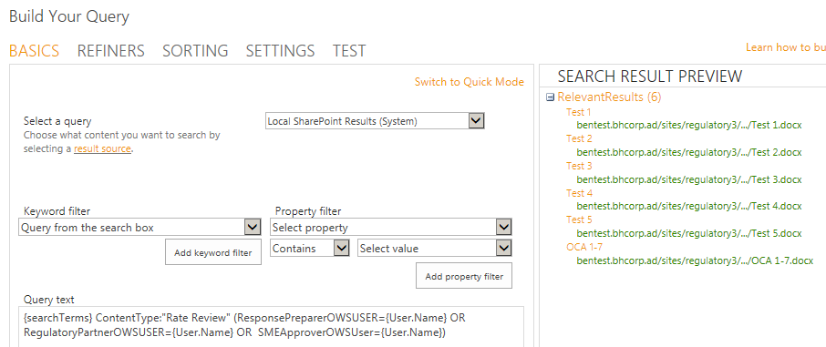

* + - 1. Click on the “Change Query” button
      2. Search Query Structure:
         1. Required Prefix – {searchTerms}
         2. Content Types, for example “Rate Review”
         3. Managed Property Filters, for example:

The current user, for example: User.Name

Field values, for example: ReviewTaskStatusOWSCHCS<>Final, PercentCompleteOWSNMBR<>1

* + - 1. From the “Build Your Query” pop-up window, in the query text section, paste the code below (overwriting any existing code):

{searchTerms} (ContentType:"Rate Review" (RegulatoryPartnerOWSUSER:{User.Name} OR SMEApproverOWSUSER:{User.Name} OR ResponsePreparerOWSUSER:{User.Name}) AND ( ReviewTaskStatusOWSCHCS<>Final AND ReviewTaskStatusOWSCHCS<>Served)) OR (ContentType:"Task” AssignedTo:{User.Name} AND PercentCompleteOWSNMBR<>1)

* + - 1. Click on the “Test query” button, some search results should appear
      2. Finally click on the OK button, this will close the Build Your Query pop-up window
      3. In the “Number of items to show” input box, enter the number 10
      4. In the Display Templates section, under the Control header, from the drop down choose “My Task Rollup List with Paging New”
      5. In the Display Templates section, under the Item header, from the drop down choose “My Task Rollup New”
      6. Finally click the “OK” button, this close the Edit Web Part pane
      7. From the Web Part page, in the ribbon, click on the “Stop Editing” button
      8. This completes the configuration of the My Tasks Rollup Web Part